SWDD- [obtain number from Conduct of Engineering Document Numbering [SharePoint site](https://coe.lanl.gov/APs/DocNum/SitePages/Home.aspx)]

PyFamilyTree group

**PyFamilyTree**

#### Software Design Document

**Name (s):**

- Artie Dana

- Muyiwa Oguntimilehin

- Ilami Erasmus

- Daniel Schmidt

Date: (04/13/2023)

**TABLE OF CONTENTS**

***1.0*** ***INTRODUCTION 3***

***1.1*** ***Purpose 3***

***1.2*** ***Scope 3***

***1.3*** ***Overview 3***

***1.4*** ***Reference Material 3***

***2.0*** ***SYSTEM OVERVIEW 3***

***3.0*** ***SYSTEM ARCHITECTURE 3***

***3.1*** ***Architectural Design 3***

***3.2*** ***Decomposition Description 4***

***3.3*** ***Design Rationale 4***

***4.0*** ***DATA DESIGN 4***

***4.1*** ***Data Description 4***

***4.2*** ***Database Schema 5***

***5.0*** ***COMPONENT DESIGN 6***

***6.0*** ***HUMAN INTERFACE DESIGN 6***

***6.1*** ***Overview of User Interface 6***

***6.2*** ***Screen Images 6-11***

***6.3*** ***Screen Objects and Actions 12***

***7.0*** ***REQUIREMENTS MATRIX 12-15***

***8.0*** ***USER MANUAL 15-20***

***9.0*** ***APPENDICES 21***

***9.1*** ***Use Cases 21-24***

***9.2*** ***User Stories 24-30***

***9.3*** ***Sequence Diagrams 30-32***

***9.4*** ***Activity Diagrams 32-38***

## INTRODUCTION

## Purpose

This Software Design Document describes the architecture and design of the PyFamilyTree application. The intended audience for this document are all stakeholders of the family tree app.

## Scope

The PyFamilyTree app is a family tree application that allows users to create and maintain family trees, add members, and keep track of genealogical information. The goals of this project are to provide a user-friendly and secure application that can handle high traffic and large amounts of data. The objectives of the project are to develop an app that is scalable, maintainable, and easily updatable.

## Overview

This document provides an overview of the PyFamilyTree app and its organization. It outlines the system architecture, data design, component design, and human interface design. The document also includes a requirements matrix to trace system components and data structures ot the requirements outlined in the Software Requirements Specification (SRS document)

## Reference Material

The reference material used for this document includes the SRS document, software development best practices, and documentation provided by the associated third-party software libraries.

## SYSTEM OVERVIEW

The PyFamilyTree app is a web-based family tree application that allows users to create and maintain family trees, add members, and keep track of genealogical information. Users can view their family tree, edit family member information, and add new family members. The app is designed to be user-friendly, scalable, and secure.

## SYSTEM ARCHITECTURE

## Architectural Design

The PyFamilyTree app is designed using a 3-tier architecture consisting of a presentation layer, application layer, and database layer. The presentation layer is responsible for the user interface and handles all user input and output. The application layer contains the business logic of the application and handles data processing. The database layer is responsible for storing and retrieving data.

## Decomposition Description

The PyFamilyTree app is decomposed into three main subsystems: the user interface subsystem, the business logic subsystem, and the data storage subsystem. The user interface subsystem handles all user input and output and communicates with the business logic subsystem to process data. The business logic subsystem contains all the application’s business logic and communicates with the data storage subsystem to store and retrieve data.

## Design Rationale

The 3-tier architecture was chosen to separate the application into distinct layers to increase modularity and scalability. This architecture also enables the use of caching and load balancing to handle high traffic and large amounts of data. The usage of a database layer allows for easy storage and retrieval, and the use of the business logic layer enables easy maintenance and updates.

## DATA DESIGN

## Data Description

The PyFamilyTree app uses a database to store all user data, including family tree information and member data .The database schema is designed to support the application’s functionality, with appropriate tables for family trees, family members, and user accounts.

## Database Schema (Entity Relationships)

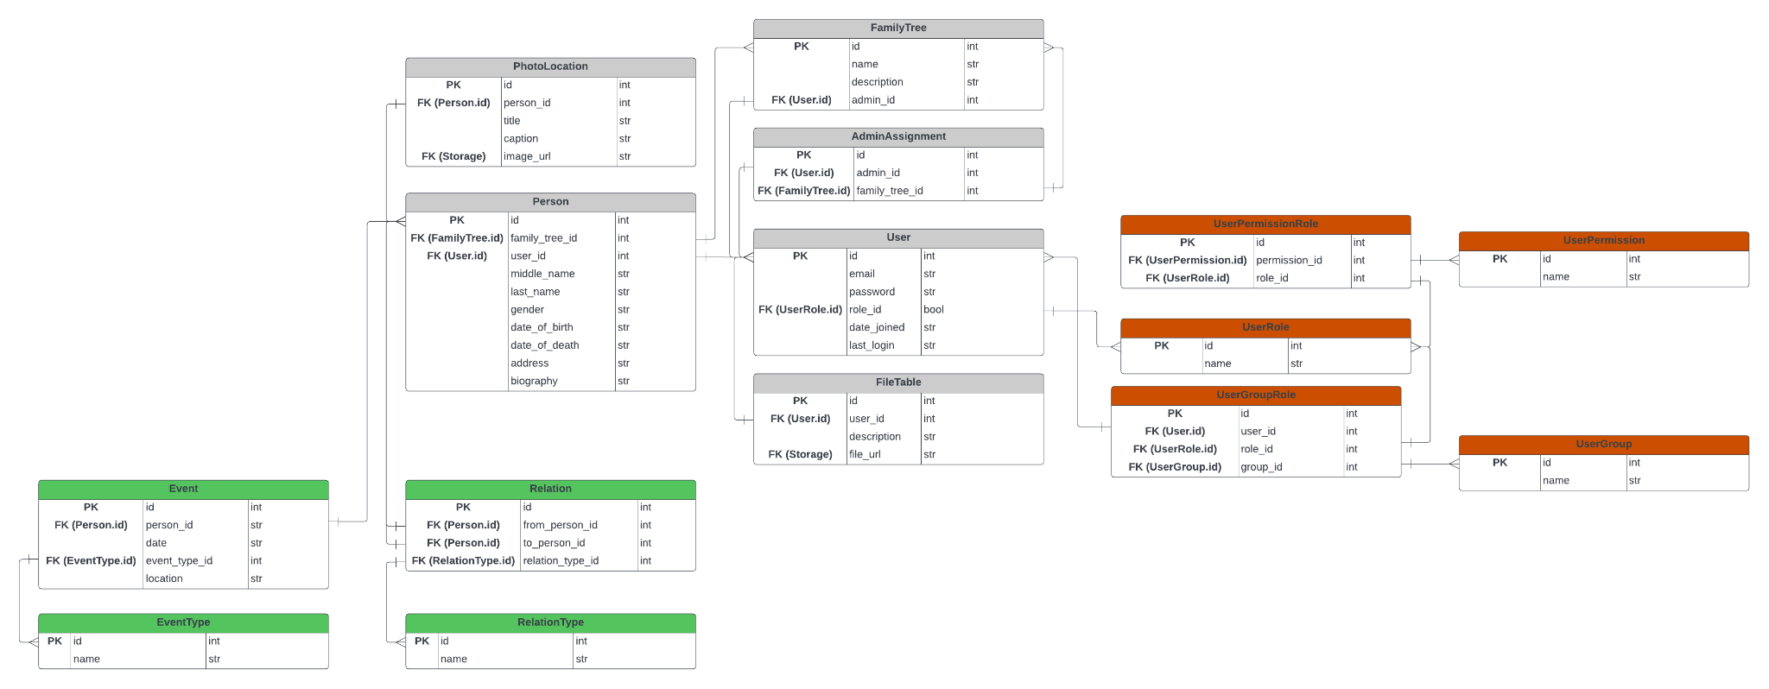

## COMPONENT DESIGN

The PyFamilyTree app is designed using a Model-View-Controller (MVC) architecture. The model contains the business logic and data processing code, the viewer handles the user interface, and the controller handles user input and communicates between the model and view.

## HUMAN INTERFACE DESIGN

## Overview of User Interface

The PyFamilyTree app is designed to be user-friendly and intuitive for all users. The user interface includes a dashboard for easy access to family trees, and family tree view for visualizing family tree structures, and tools for adding and editing family member information.

## Screen Images

##### GUI ID 1: Home Page

The home page serves as the landing page for our web app. You can select the links to login or sign up.

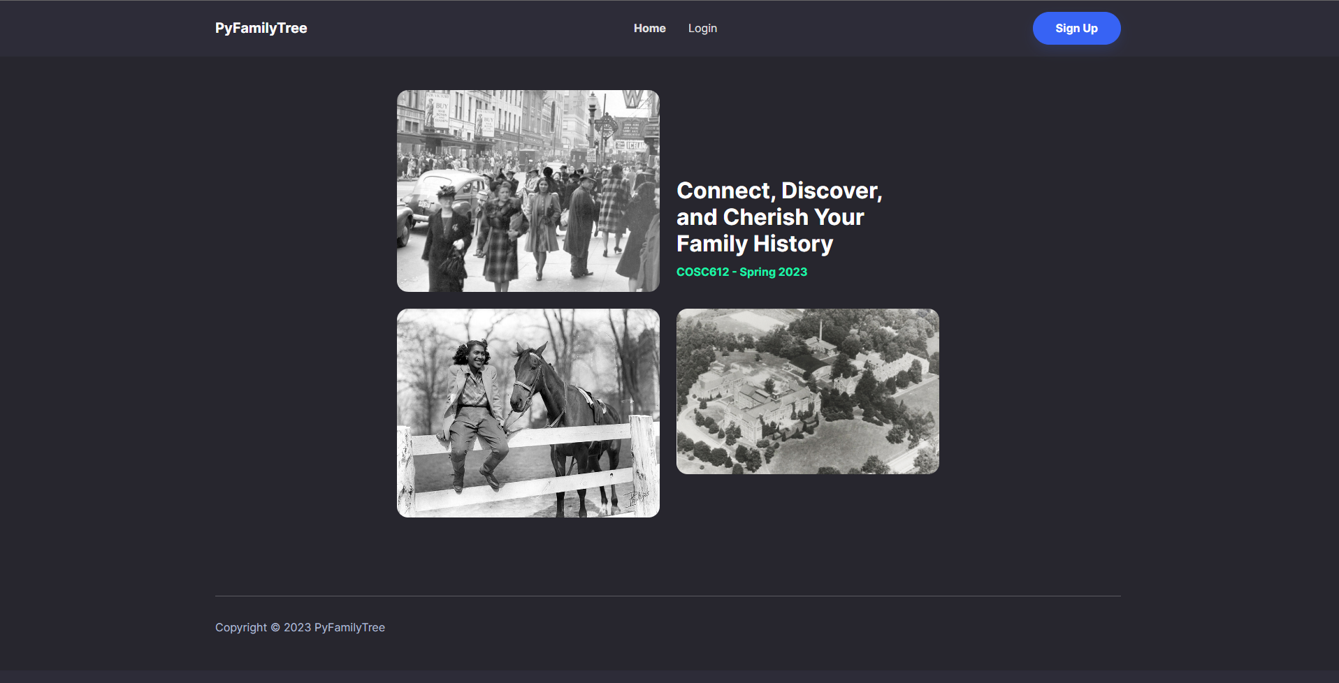

##### GUI ID 2: Login

The login screen allows members and administrators to enter their credentials and login to the web application.

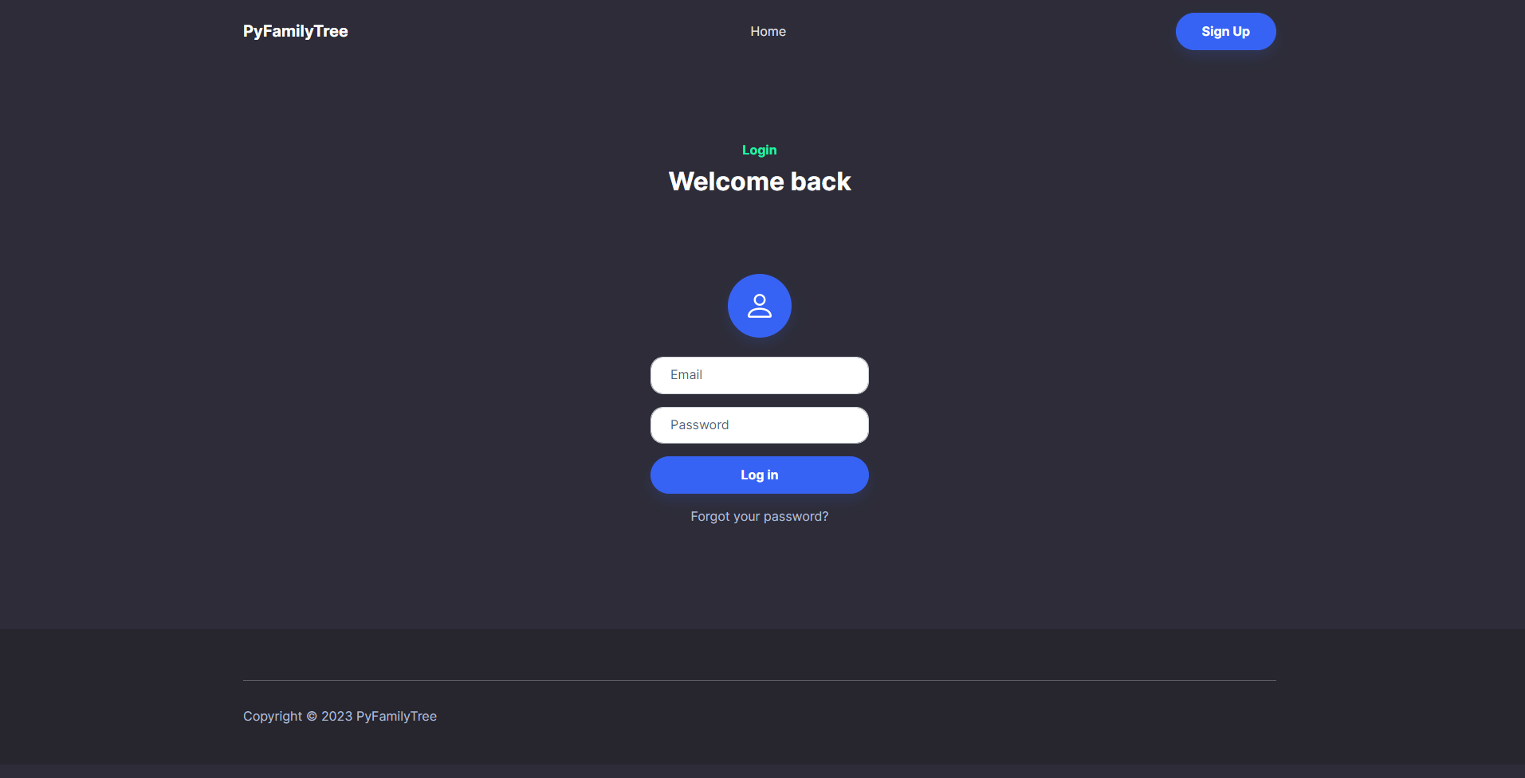

##### 

##### 

##### 

##### GUI ID 3: Registration

The registration page allows a potential new user to submit a self registration request. They need to know the name of the family tree they would like to join.

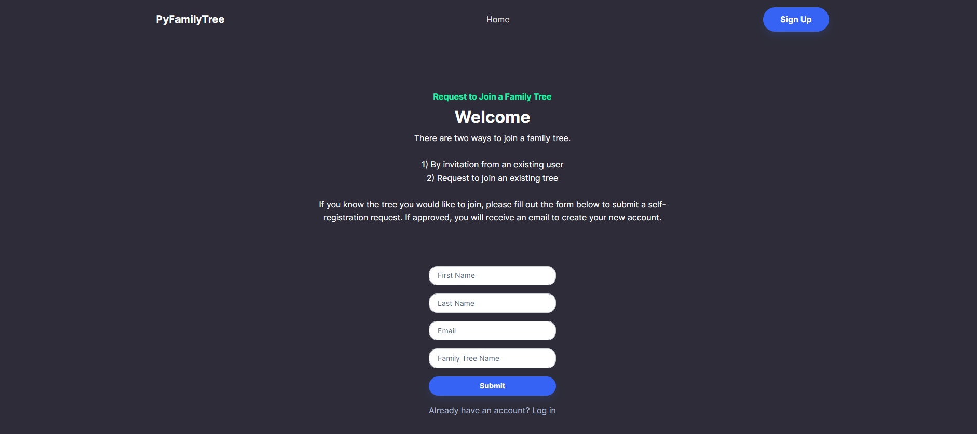

##### GUI ID 4: Create Profile

The create profile page will be sent via an email link to a potential family member once their self registration request is approved or if they are invited to a family tree by an existing member. Here a new user will be able to create their account by entering their email and password.

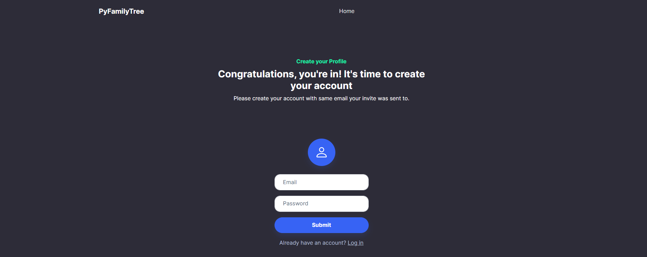

##### GUI ID 5: Edit Profile

Family members and administrators can use the edit profile page to update their information. This information is visible on the family tree.

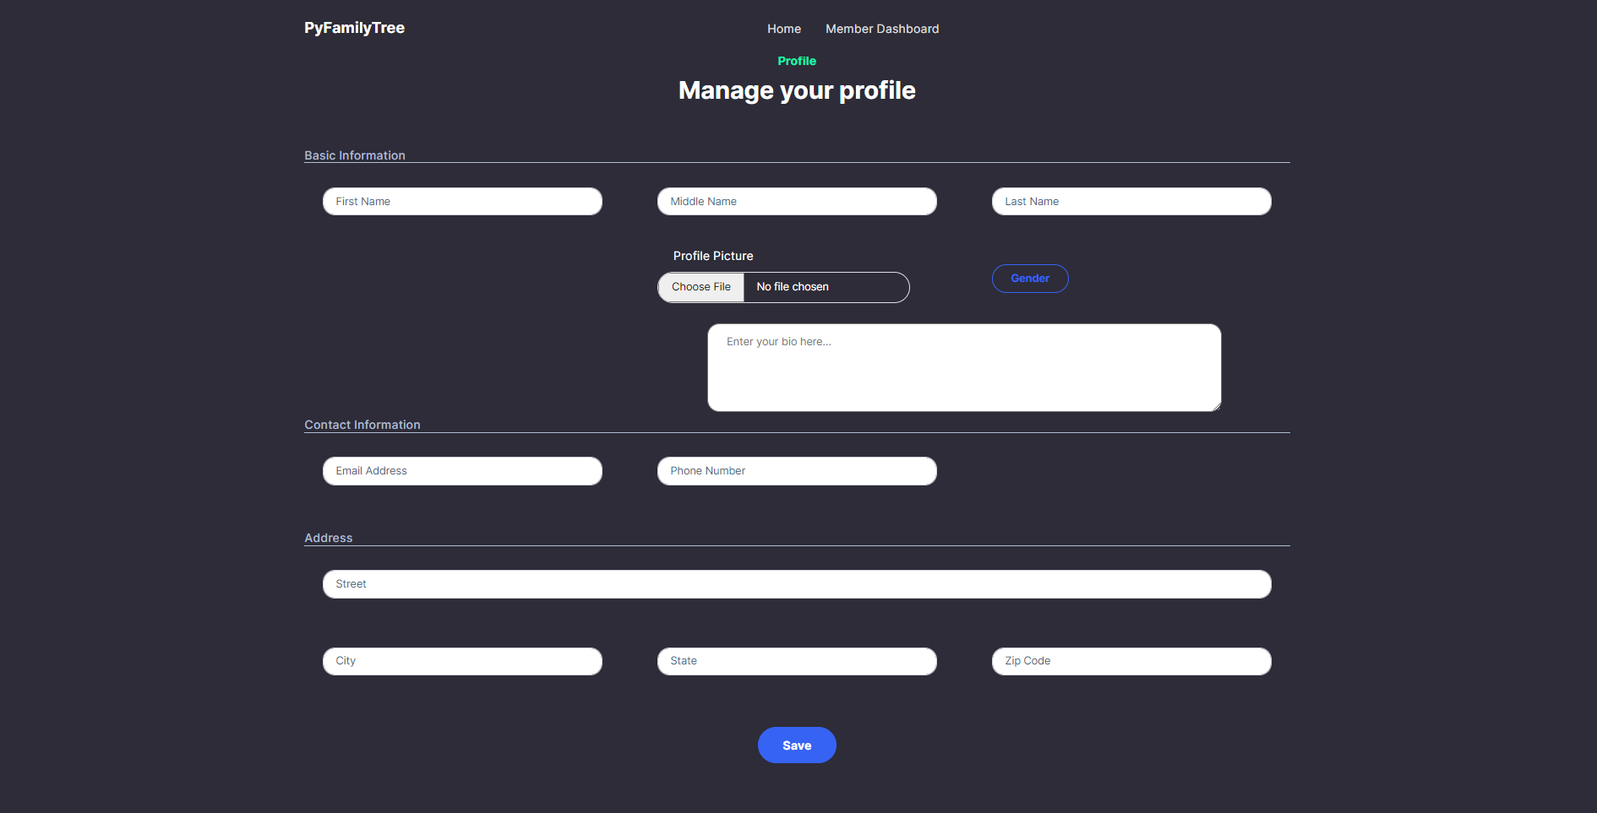

##### GUI ID 6: Member Information

The member information page displays all know information about a queried family member. You can also see relationships between different members and select profiles of specific members to learn more about them.

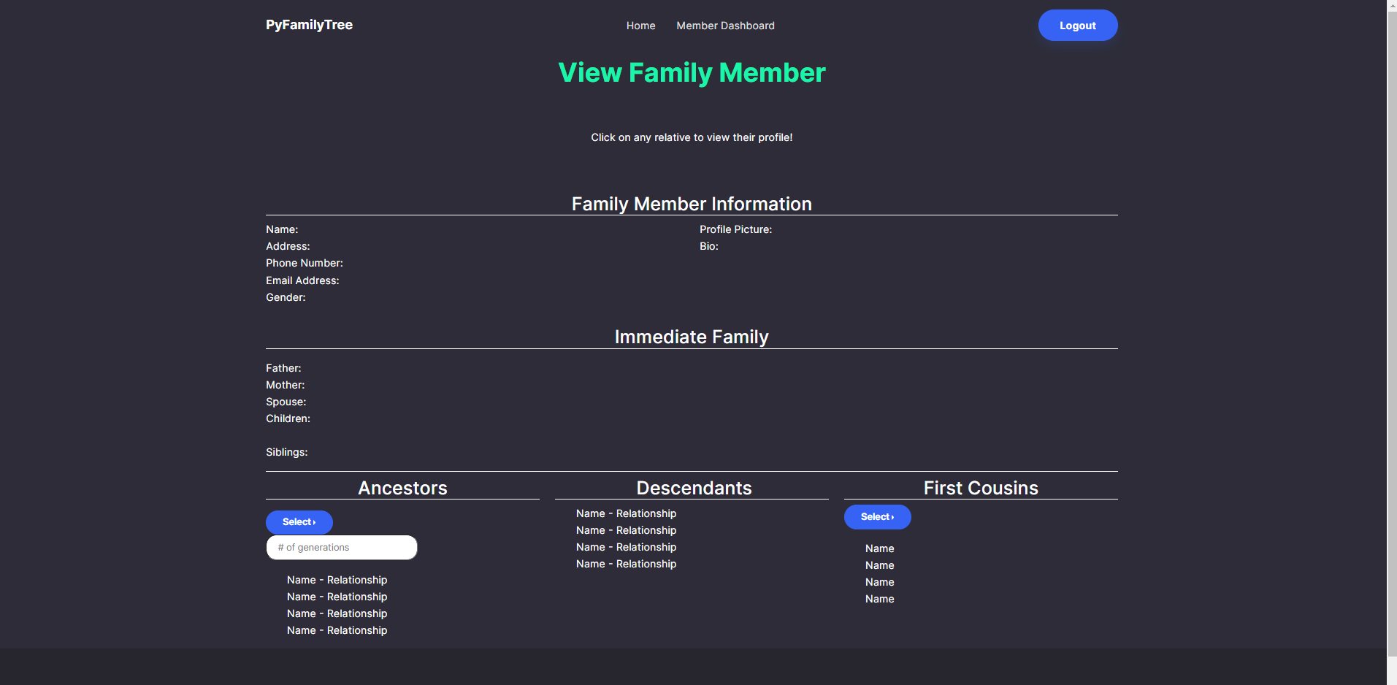

##### 

##### GUI ID 7: Member Dashboard

The member dashboard is a landing page for users once they are logged into the application. It displays a profile preview, links to cloud storage, and allows family members to search the family tree. Members can also invite someone to join the family tree.

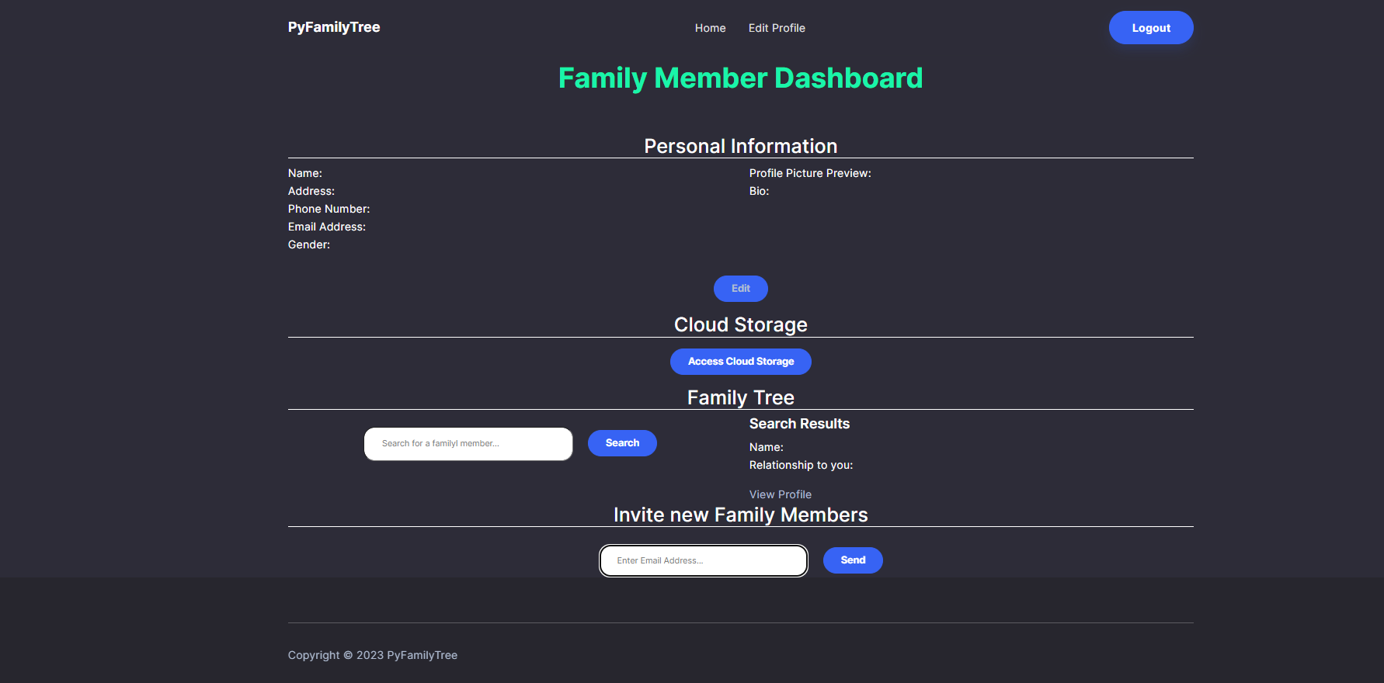

##### 

##### 

##### GUI ID 8: Administrator Dashboard

The administrator dashboard allows administrators to approve or decline pending requests to join a family tree. Super Administrators can also create a new family tree and approve and demote admins for specific family trees.

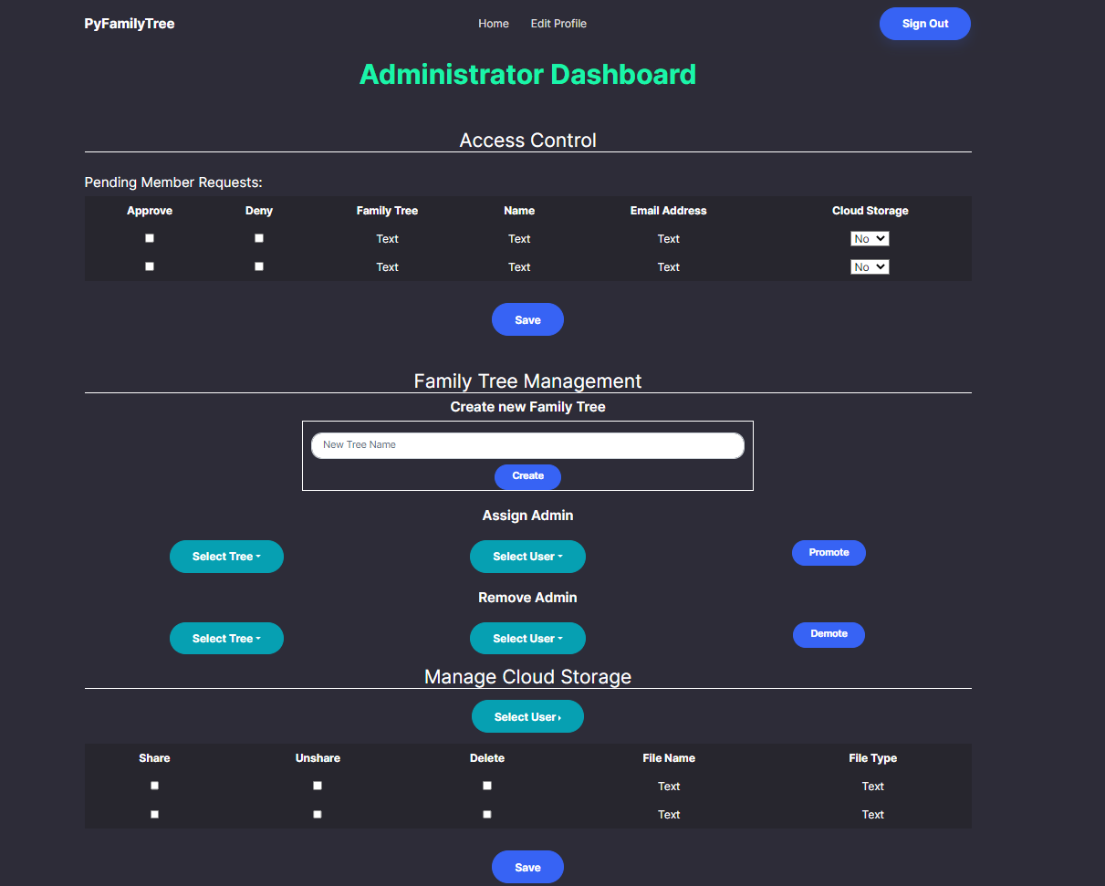

##### GUI ID 9: Cloud Dashboard

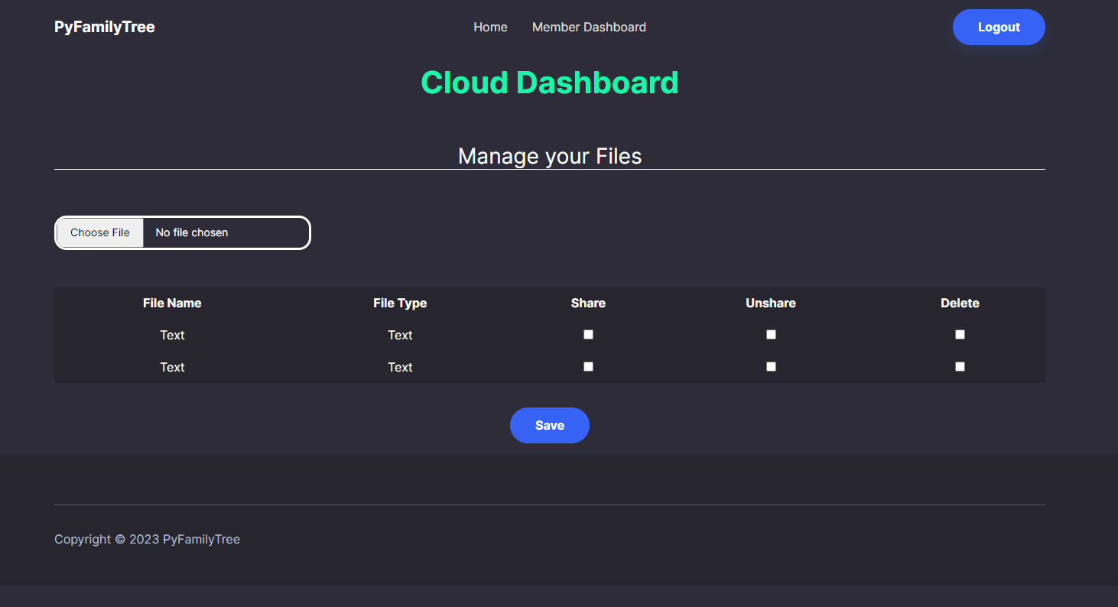

## Screen Objects and Actions

The PyFamilyTree app includes the following screen objects and actions:

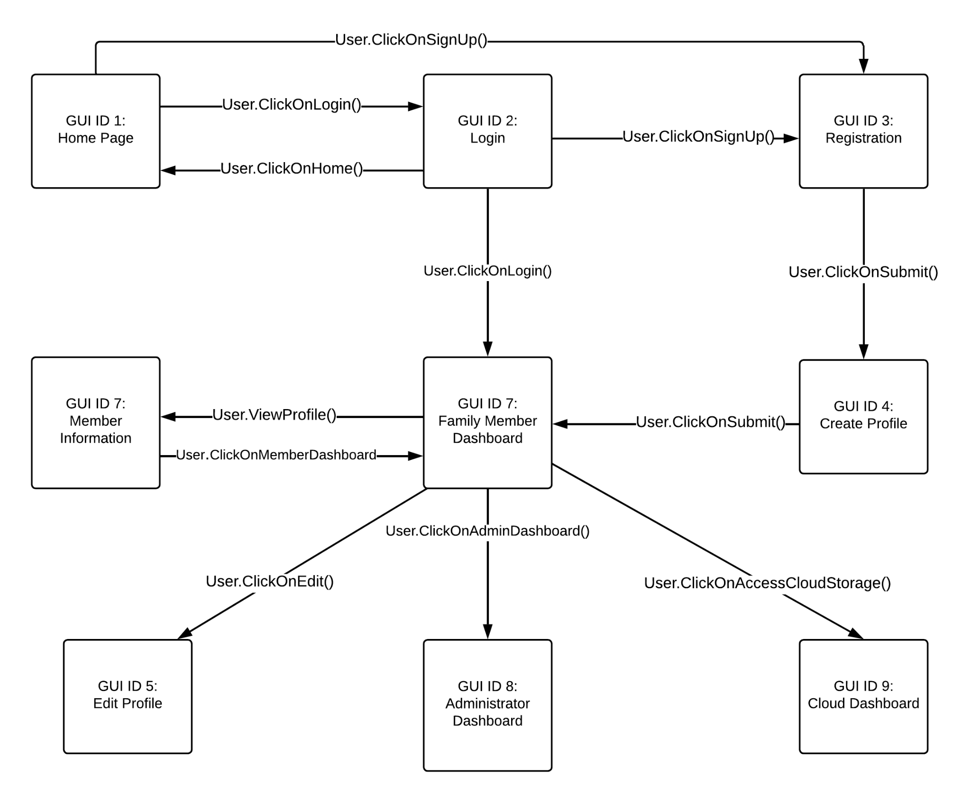

## REQUIREMENTS MATRIX

The requirement matrix traces components and data structures to the requirements outlined in the SRS document. It ensures that all requirements are met by the system components.

| **User Story ID** | **User Story Name** | **Use Case ID** | **Sequence Diagram ID** | **Activity Diagram ID** | **GUI ID** | **User Manual Section ID** |
| --- | --- | --- | --- | --- | --- | --- |
| **1** | New Family Tree Creation | unmapped | 9.2 | 1 | 8 | 8.1 |
| **2** | Assigning an Admin to an Existing family | 10 | 9.1 | 1 | 8 | 8.2 |
| **3** | Inviting My Family to Our Family Tree | 3 | 9.1 | 4 | 7 | 8.3 |
| **4** | Accepting an Invitation to a Family Tree | 2 | 9.1 | 4 | 4 | 8.4 |
| **5** | Requesting to Join a Family Tree | 2 | 9.1 | 4 | 3 | 8.5 |
| **6** | Approving a Request to Join a Family Tree | 3 | 9.1 | 4 | 8 | 8.6 |
| **7** | Denying a Request to Join a Family Tree | 3 | 9.1 | 4 | 8 | 8.7 |
| **8** | Blocking an Email Address from Requesting to Join a Family Tree | 3 | Unmapped | 1 | unmapped | 8.8 |
| **9** | Specify the Relationship of a New Member In My Family Tree | 5 | Unmapped | unmapped | unmapped | 8.9 |
| **10** | Update My Name | 5 | 9.1 | 2 | 5 | 8.10 |
| **11** | Adding a Profile Picture | 5 | 9.2 | 2 | 5 | 8.11 |
| **12** | Adding My Family Members’ Information To My Record | 5 | 9.1 | 2 | unmapped | 8.12 |
| **13** | Changing An Email Address | 5 | 9.1 | 2 | 5 | 8.13 |
| **14** | Change Account Password | 6 | 9.2 | 2 | 2 | 8.14 |
| **15** | Update A Temporary Password | 6 | 9.2 | 2 | 2 | 8.15 |
| **16** | Add Phone Number Personal Record | 5 | 9.1 | 2 | 5 | 8.16 |
| **17** | Add Address To Personal Record | 5 | 9.1 | 2 | 5 | 8.17 |
| **18** | Update Personal Bio | 5 | 9.1 | 2 | 5 | 8.18 |
| **19** | Search for Immediate Family | 4 | 9.1 | 5 | 6 | 8.19 |
| **20** | Search for Extended Family | 4 | 9.1 | 5 | 6 | 8.20 |
| **21** | Search for Individual | 4 | 9.1 | 5 | 7 | 8.21 |
| **22** | Assign Cloud Storage | 7 | 9.1 | unmapped | 8 | 8.22 |
| **23** | Upload to cloud storage | 8 | 9.2 | 6 | 7 | 8.23 |
| **24** | Share Media through link | 8 | 9.2 | 6 | 9 | 8.24 |
| **25** | Delete Media | 8 | 9.2 | 6 | 9 | 8.25 |
| **26** | Unshare Media | 8 | 9.2 | 6 | 9 | 8.26 |
| **27** | Admin update sharing | 8 | 9.2 | 6 | 8 | 8.27 |
| **28** | Update Database Directly | unmapped | unmapped | unmapped | unmapped | 8.28 |
| **29** | Content Control | 9 | unmapped | 1 | unmapped | 8.29 |
| **30** | Family-specific Content Control | 9 | unmapped | 1 | unmapped | 8.30 |
| **31** | Security-related Upload Filtering | 9 | unmapped | 1 | unmapped | 8.31 |
| **32** | Admin Removal of Media | 9 | unmapped | 6 | 8 | 8.32 |
| **33** | Access Definition for a given Folder/File | 9 | Unmapped | 6 | unmapped | 8.33 |

## 

## 8.0 User Manual

8.1 New Family Tree Creation:

* Login to the system with Super admin credentials
* Click on the “Create Family Tree” button located on the dashboard.
* Fill in the necessary details, such as family name and family description.
* Once all details are entered, click on the “Create” button to submit.
* The new family tree is now created and ready to use.

8.2 Assigning an Admin to an Existing Family:

* Login to the system with Super admin credentials
* Click on the “Admin” tab on the dashboard
* Search for the family you wish to assign an admin to and click on it.
* Click on the “Add Admin” button and fill in the details of the person you want to assign as the admin.
* Once all details are entered, click on the “Add” button to submit.
* The admin is now successfully assigned to the family.

8.3 Inviting My Family to Our Family Tree:

* Login to the system with Super admin or Admin credentials
* Click on the “Invite Members” button on the dashboard.
* Enter the email addresses of the family members you wish to invite.
* You can also personalize the message to the invitees.
* Once all the details are entered, click on the “Send Invitation” button to submit.
* The invitees will receive an email invitation to join the family tree.

8.4 Accepting an Invitation to a Family Tree:

* Check your email for the invitation link.
* Click on the invitation link to open the signup page.
* Fill in the necessary details to create an account and click on the “Signup” button to submit.
* You will now have access to the family tree.

8.5 Requesting to Join a Family Tree:

* Login to the system with your credentials.
* Click on the “Join a Family Tree” button on the dashboard.
* Enter the name of the family tree you wish to join and click on the “Request to Join” button.
* The family tree admin will receive your request and respond accordingly.

8.6 Approving a Request to Join a Family Tree:

* Log in to the family tree application with your credentials.
* Navigate to the family tree dashboard.
* Click on the "Requests" tab to view the list of pending join requests.
* Review the details of the request, including the potential member's name and email address.
* Click on the "Approve" button to add the member to the family tree.
* The member will receive an email notification informing them that their request has been approved.
* Once approved, the member can access the family tree with the appropriate permissions.

8.7 Denying a Request to Join a Family Tree:

* Log in to the family tree application with your credentials.
* Navigate to the family tree dashboard.
* Click on the "Requests" tab to view the list of pending join requests.
* Review the details of the request, including the potential member's name and email address.
* Click on the "Deny" button to reject the member from joining the family tree.
* The member will receive an email notification informing them that their request has been denied.
* Once denied, the member cannot access the family tree.

8.8 Blocking an Email Address from Requesting to Join a Family Tree:

* Log in to the family tree application with your credentials.
* Navigate to the family tree dashboard.
* Click on the "Settings" tab to access the family tree settings.
* Scroll down to the "Blocked Email Addresses" section.
* Enter the email address you want to block and click the "Add" button.
* The email address is added to the blocked list in the database and cannot be used again to request to join the family tree.
* If the email address is used again, an alert is prompted.

8.9 Specify the Relationship of a New Member In My Family Tree:

* Log in to your account and navigate to the page where you can add a new member to your family tree.
* Enter the details of the new member, including their name and birth date, if available.
* In the appropriate fields, specify the new member's relationship to their father, mother, spouse, and children. If the new member has no father or mother specified, select "Unknown".
* Click the "Save" button to save the new member's details and their relationship to their family members.
* The new member's details will now be stored in the appropriate database tables, and their relationship to their family members will be displayed correctly in the GUI.

8.10 Update My Name:

* Log in to your account and navigate to the page where you can update your personal information.
* Find the fields for "First Name," "Middle Name," and "Last Name."
* Update your name in the appropriate fields by typing over the existing information.
* Click the "Save" button to save your updated information.
* The database will now be updated with your new name, and the updated name can be successfully queried.

8.11 Adding a Profile Picture:

* Log in to your account and navigate to the page where you can edit your personal information.
* Click the "Choose File" button and select the picture you want to upload from your local device.
* The picture will be uploaded to the associate cloud storage, and a pointer/link to the database will be created.
* Click the "Save" button to save your updated information.
* The database will now be updated with the link to your profile picture, and users with permissions can see your picture in the GUI.

8.12 Adding My Family Members’ Information To My Record:

* Log in to your account and navigate to the page where you can edit your personal information.
* Find the fields for "Father," "Mother," "Spouse," and "Children."
* Search for the family member you want to add by entering their name in the search field.
* When the correct family member is highlighted, click on their name to add them to your record.
* Click the "Save" button to save your updated information.
* The database will now be updated with the added family members' information, and they will be displayed correctly in the GUI.

8.13 Changing An Email Address:

* Log in to your account and navigate to the page where you can edit your personal information.
* Find the field for "Email Address."
* Enter your new email address in the field.
* Click the "Save" button to save your updated information.
* The database will now be updated with your new email address, and users with permissions can see your updated email address. You can now use your new email address to log in.

8.14 Change Account Password:

* Login to your account on the family tree application using your current password.
* Click on your profile icon, located in the top-right corner of the screen.
* Select "Account Settings" from the dropdown menu.
* On the "Account Settings" page, click on the "Change Password" button.
* Enter your current password and your new password in the appropriate fields.
* Click on the "Save Changes" button.

8.15 Update A Temporary Password:

* Login to your account on the family tree application using your temporary password.
* Click on your profile icon, located in the top-right corner of the screen.
* Select "Account Settings" from the dropdown menu.
* On the "Account Settings" page, click on the "Change Password" button.
* Enter your temporary password in the "Current Password" field and your new password in the "New Password" field.
* Click on the "Save Changes" button.

8.16 Add Phone Number Personal Record:

* Login to your account on the family tree application.
* Click on your profile icon, located in the top-right corner of the screen.
* Select "Edit Profile" from the dropdown menu.
* On the "Edit Profile" page, scroll down to the "Phone Number" section.
* Enter your phone number in the appropriate field.
* Click on the "Save Changes" button.

8.17 Add Address To Personal Record:

* Login to your account on the family tree application.
* Click on your profile icon, located in the top-right corner of the screen.
* Select "Edit Profile" from the dropdown menu.
* On the "Edit Profile" page, scroll down to the "Address" section.
* Enter your street address, city, state, and zip code in the appropriate fields.
* Click on the "Save Changes" button.

8.18 Update Personal Bio:

* Log in to your family tree account
* Click on your profile or personal record
* Find the field labeled "Bio" or "About Me" and click on it
* Update or add your bio information in the text field provided
* Click "Save" or "Update" to save your changes

8.19 Search for Immediate Family:

* Log in to your family tree account
* Click on the search bar or the "Search" button
* Type in the name of the immediate family member you are looking for
* Click "Search" or hit enter
* Select the correct family member from the search results
* View their contact information in their personal record

8.20 Search for Extended Family:

* Log in to your family tree account
* Click on the search bar or the "Search" button
* Type in the name of the extended family member or ancestor you are looking for
* Click "Search" or hit enter
* Select the correct family member or ancestor from the search results
* View their personal record to learn more about them

8.21 Search for Individual:

* Log in to your family tree account
* Click on the search bar or the "Search" button
* Type in the name of the family member you are looking for
* Click "Search" or hit enter
* Select the correct family member from the search results
* View their personal record to see their connections in the family tree

8.22 Assign Cloud Storage:

* Log in to your Family Tree account.
* Click on the "Media" tab in the navigation bar.
* Click on the "Upload" button.
* Select the media file you want to upload from your device.
* Wait for the upload to complete and click on the "Save" button to confirm.

8.23 Upload to cloud storage:

* Log in to your Family Tree account.
* Click on the "Media" tab in the navigation bar.
* Click on the "Upload" button.
* Select the media file you want to upload from your device.
* Wait for the upload to complete and click on the "Save" button to confirm.

8.24 Share Media through link:

* Log in to your Family Tree account.
* Click on the "Media" tab in the navigation bar.
* Find the media file you want to share and click on the "Share" button.
* Click on the "Create Link" button.
* Copy the link that appears and share it with the family member you want to share the media with.

8.25 Delete Media:

* Log in to your Family Tree account.
* Click on the "Media" tab in the navigation bar.
* Find the media file you want to delete and click on the "Delete" button.
* Confirm the deletion by clicking on the "Yes" button.

8.26 Unshare Media:

* Log in to your Family Tree account.
* Click on the "Media" tab in the navigation bar.
* Find the media file you want to make unshareable and click on the "Edit" button.
* Uncheck the "Shareable" checkbox.
* Click on the "Save" button to confirm the changes.

8.27 Admin update sharing:

* Login to the family tree account with admin credentials.
* Navigate to the media file that needs to be modified.
* Click on the "Edit" button for that media file.
* Modify the sharing option to "share" or "unshare" as needed.
* Click on the "Save" button to update the sharing option.

8.28 Update Database Directly:

* Login to the database account with DBA credentials.
* Navigate to the table that needs to be modified.
* Click on the "Edit" button for that table.
* Modify the data as needed.
* Click on the "Save" button to update the data in the database.

8.29 Content Control:

* Login to the family tree account with super admin credentials.
* Navigate to the "Settings" option in the account menu.
* Click on the "Terms of Service" option.
* Modify the acceptable content classes as needed.
* Click on the "Save" button to update the terms of service.

8.30 Family-specific Content Control:

* Login to the family tree account with admin credentials.
* Navigate to the media file that needs to be blocked.
* Click on the "Edit" button for that media file.
* Modify the content class to be blocked.
* Click on the "Save" button to update the content control.

8.31 Security-related Upload Filtering:

* Login to the family tree account with super admin/admin credentials.
* Navigate to the "Settings" option in the account menu.
* Click on the "Upload Filtering" option.
* Modify the upload filtering criteria as needed.
* Click on the "Save" button to update the upload filtering.

8.32 Admin Removal of Media:

* Login to the family tree account as a Super Admin or Admin.
* Navigate to the user account that contains the media file to be removed.
* Click on the "Shared Cloud" option in the user's account menu.
* Locate the media file to be removed and select it.
* Click on the "Delete" button to remove the media file from the shared cloud storage.
* Confirm the deletion by clicking "Yes" on the confirmation message.

8.33 Access Definition for a given Folder/File:

* Login to the family tree account as an Admin or Member.
* Navigate to the shared folder or file that you want to define access for.
* Click on the "Access" option for the folder or file.
* Select "Read Only" or "Write" for the access level you want to grant to other users.
* Save the changes by clicking on the "Save" button.
* The folder or file will now be restricted to the access level you defined, preventing other users from modifying or removing it without your permission.

## 9.0 APPENDICES

### 9.1 Use Cases:

| Use Case | User login |
| --- | --- |
| ID | 01 |
| Actors | Super Admin, Admin, Family Member |
| Description | All users must login to the PyFamilyTree web application to access or manage Family Trees. |
| Data | The users username and password |
| Stimulus | The user visits the login webpage |
| Response | The user is successfully logged into the application, or if an incorrect username/password combination is entered then an error message is presented to the user. |
| Comments | The user must already have an account to login, otherwise they have the option to request to join a family tree. |

| Use Case | Request to join a family tree |
| --- | --- |
| ID | 02 |
| Actors | Potential Family Member |
| Description | A potential family member may request to join an existing family tree. If an invite is accepted by the admin, the potential family member can create a user account and contribute to the family tree. |
| Data | The requester's first name, last name, email, family tree, and a comment on their relationship to the requested family tree. |
| Stimulus | A request to join form is filled out and submitted by the requester |
| Response | The request to join is received by the family tree admins. Then the admins can decide to approve or deny the request. |
| Comments | The requester must know the name of the family tree they wish to join. |

| Use Case | Invite a potential family member to join your family tree |
| --- | --- |
| ID | 03 |
| Actors | Super Admin, Admin, Family Member |
| Description | A family member or admin can send an email invitation to join their family tree to a potential family member. Entering the family tree will consist of creating a user account and enabling the ability to update profile information that will contribute to the family tree. |
| Data | Potential family member's first name, last name, and email address |
| Stimulus | An admin or family member fills out an invitation form with the potential family member's name and email address |
| Response | The invitee receives a family tree join invitation via email. |
| Comments | A valid email address is required for the invitation to be successfully sent by an admin |

| Use Case | Search the family tree for immediate family members |
| --- | --- |
| ID | 04 |
| Actors | Super Admin, Admin, Family Member |
| Description | A family member can search for any target member in the family tree and then view the queried member's immediate family. If an existing family member is searched, the results should include (if applicable) parents, self, children, in-laws, and grandchildren |
| Data | Family member profile with links to profiles of related family members. Self, parents, children, in-laws, and grandchildren |
| Stimulus | A search is entered into the family tree search box |
| Response | A successful or unsuccessful search result is returned. If the family member is found, their profile will be shown on the screen. If not, an error message stating that the family member could not be found in the tree. |
| Comments |  |

| Use Case | Edit profile information |
| --- | --- |
| ID | 05 |
| Actors | Super Admin, Admin, Family Member |
| Description | The user profile contains all pertinent information about an individual family member. Other family members can view the profile to learn more about a particular family member. A family member needs to be able to update their profile information so it is accurately reflected in the family tree. |
| Data | First name, middle name, profile picture, address, immediate family, phone number, bio, email address |
| Stimulus | Family members can select Edit profile from their personal profile page. |
| Response | After entering a valid update, changes are saved into the database and visible to any family member that views the updated profile. |
| Comments | Data validity rules apply to each of the fields that can be updated. |

| Use Case | Change password |
| --- | --- |
| ID | 06 |
| Actors | Super Admin, Admin, Family Member |
| Description | All credentialed users must be able to change their password for security reasons or if they forgot their current password. They can change their password from within the PyFamilyTree application or request a link be sent to their email to change their password. |
| Data | Username and password |
| Stimulus | A user navigates to their profile and selects *change password*. Alternatively, if the user forgot their password, from the login screen they can request to have a request link sent to their email. |
| Response | User is prompted with a successful password change message with a link to go back to the login page. |
| Comments | If a valid email is not entered for the *forgot a password* function, the user will not receive a password reset email. |

| Use Case | Assign cloud storage to family members |
| --- | --- |
| ID | 07 |
| Actors | Super Admin, Admin |
| Description | Admins can allocate cloud storage to family members. Storage can be used by family members to upload media and is directly accessible via their profile after a login |
| Data | Cloud storage space, cloud storage availability |
| Stimulus | Admin creates a new folder and sets appropriate permission so only the admins and assigned family members can modify and upload to the cloud storage space. |
| Response | The family member will see a cloud storage link the next time they log in to the application and view their profile. |
| Comments | Admins can increase storage space per request. |

| Use Case | Upload media to assigned cloud storage |
| --- | --- |
| ID | 08 |
| Actors | Super Admin, Admin, Family Member |
| Description | Family members with assigned cloud storage can upload media files to their storage space. This includes photos, videos, and audio recordings. |
| Data | Media file, photo, video and audio files |
| Stimulus | A user opens their cloud storage and selects to upload a new media file |
| Response | The media file is uploaded to their cloud storage space if the selected file is valid. Otherwise, an error message explaining which file types are valid for upload is presented to the user. |
| Comments |  |

| Use Case | Edit sharing settings on uploaded media |
| --- | --- |
| ID | 09 |
| Actors | Super Admin, Admin, Family Member |
| Description | Family members can select individual media files and set sharing settings. Media files can either be private or shared with all family members. Shared media files are found in a family member's profile. |
| Data | Media file |
| Stimulus | A family member selects a media file from their shared storage and sets the sharing settings. |
| Response | The sharing settings are updated, and the visibility of the media file to other family members is immediately changed based on the new selection, share or unshare. |
| Comments |  |

| Use Case | Assign an admin to the family tree |
| --- | --- |
| ID | 10 |
| Actors | Super Admin |
| Description | Super admins can assign admins to a family tree. An admin will have the ability to invite and remove users from a family tree. They can also assist with sharing/unsharing media content for individual family members. |
| Data | Username of family member to be promoted to admin |
| Stimulus | Super admin can select any standard user from the user administration page and promote them to an admin |
| Response | The promoted user receives an alert that they have be given admin access to the family tree. They now can login to the family tree admin page. |
| Comments | Admins are critical in ensuring the family tree can be updated and joined by any family members. |

### 9.2 User Stories:

| User Story ID | User Story Name | As a <type of user> | I want to <perform some task> | So that I can <achieve some goal> | Success Criteria |
| --- | --- | --- | --- | --- | --- |
| 1 | New Family Tree Creation | Super admin | I want to create a new family tree | So that I can document my family history and share it with family members | Being able to create a new family - by entering it into the database and accessing it through the GUI |
| 2 | Assigning an Admin to an Existing family | Super admin | Assign an admin to my family tree | So that they can share the responsibility of approving new members within our tree | The admin is successfully assigned to a particular family, and has all necessary credentials/ permissions |
| 3 | Inviting My Family to Our Family Tree | Super admin or admin | Invite my family members to join our tree | So that they can view and contribute to our tree | The admin successfully sent out an email invitation to a new member. This email was received by the target prospective member. |
| 4 | Accepting an Invitation to a Family Tree | Potential member | Accept an invitation from my family tree’s admin to join our family tree | So I can sign up and access our family tree | The potential member was successfully forwarded to the signup page |
| 5 | Requesting to Join a Family Tree | Potential member | Request to join a particular family tree | So I can view and contribute to my family tree | Family tree admin is prompted with a join request |
| 6 | Approving a Request to Join a Family Tree | Super admin or admin | Approve requests from family members to join my family tree | So they can view and contribute to my family tree | A potential member’s request is successfully approved by the admin, adding them to the family tree. . |
| 7 | Denying a Request to Join a Family Tree | Super admin or admin | Deny request to join my family tree | So that only family members I want can view and contribute to our family tree. | A potential member’s request is denied by the admin, rejecting their request. |
| 8 | Blocking an Email Address from Requesting to Join a Family Tree | Super admin or admin | Block an email address from submitting requests to join a particular family tree | So that non-family members and bad actors would be successfully blocked from joining a family tree | A given email address is successfully added to a blocked list (existing in the database), and the email address cannot be used again to request to join. If this email address is used again, an alert is prompted. |
| 9 | Specify the Relationship of a New Member In My Family Tree | Super admin or admin | Specify where a new member belongs in my family tree | So that I can add them to the appropriate location within the tree | A new/existing member now has information in the “father”, “mother”, “spouse”, and “children” fields in the appropriate table, and can be shown correctly in the GUI |
| 10 | Update My Name | Member | Update my name for my record | So that I can contribute accurate information to the tree | The firstName, middleName and lastName fields in the database are updated, can be successfully queried |
| 11 | Adding a Profile Picture | Member | Add a profile picture to my the associate cloud storage and a pointer/link to the database | So family will recognize my record by face | The user’s row in the database successfully points to the correct cloud storage location, and the picture can be viewed by users with permissions to see it. |
| 12 | Adding My Family Members’ Information To My Record | Member | Enter information relating to each family member’s (parents, spouse, children) names into my record | So that I can accurately document my relationship to my family members. | the queried family member is highlighted (via the search), and is added to the user’s information |
| 13 | Changing An Email Address | Member | Change my email address | So that I will update my login information and other family members will have the information necessary to contact me by email. | The member can now use their new email address to log in, and users with permissions can see their new email address |
| 14 | Change Account Password | Member | Change family tree account password | So I could change my password if I’m concerned that it’s been shared or if I forgot my password. | The member’s password is updated, and can be used in a fresh log in. |
| 15 | Update A Temporary Password | Member | to be able to select my own password instead of the default password | So my password will be unique to me. | The member successfully logs in with their new password |
| 16 | Add Phone Number Personal Record | Member | Enter a phone number into my record | So that other family members can contact me by phone if they would like | Phone number field is correctly populated for the member in the database, passes an error check for the correct number of digits, and is viewable by other members of the family tree. |
| 17 | Add Address To Personal Record | Member | Add address | So that other family members have my address for mail, family gatherings, or emergencies. | Physical address is correctly populated for the member in the database, passes an error check for street, city, state, and zip code, and is viewable by other members of the family tree. |
| 18 | Update Personal Bio | Member | Add/update my bio on my record | To have a written description of myself and my relationship to our family | Bio field is updated in the database, and is viewable by other members of the Family tree. |
| 19 | Search for Immediate Family | Member | Find my immediate family | So I can look up their contact information | Immediate family members (mother, father, spouse, and children) are correctly queried and displayed. |
| 20 | Search for Extended Family | Member | Find my extended family and ancestors | So I can learn more about who I am related to. | Extended family members are correctly queried (by textbox/GUI) and displayed. |
| 21 | Search for Individual | Member | Search for a specific family member | So I can view their record and see their connections in the family tree | The individual is displayed correctly, allowing the searcher to notice if the target exists and, if it does, to identify their location in the family tree. |
| 22 | Assign Cloud Storage | Super admin / admin | Assign cloud storage to members | So they can add media to share with our family | Family member’s account includes 5 GBs of cloud storage. |
| 23 | Upload to cloud storage | Member | Upload media to my record | So I can create a record with photos, documents etc | An approved file (.img, .png, .mp4, .pdf, and .docx) is successfully uploaded to the user’s assigned storage. |
| 24 | Share Media through link | Member | Share my media with other family members through a sharable link | So other members can learn more about me through photos and documents. | Shared media is successfully accessed via shareable link by another Family member. Notification sent to the media owner. |
| 25 | Delete Media | Member | Delete my media | If I make a mistake or no longer want that media available to others | The media file has been successfully deleted. |
| 26 | Unshare Media | Member | Make my media unshareable | I am not ready to share with others yet but won’t want to delete | The media file is now unavailable to users other than the source and admins. |
| 27 | Admin update sharing | Admin | Modify sharing credentials for different media files | So the admin would be able to assist family members in correctly sharing their content | The file’s sharing option is successfully modified between share and unshare. |
| 28 | Update Database Directly | Database Administrator | Modify information in the database | So the DBA would be able to ensure data quality | The existing data in the database is modified in an expected behavior, per the DBA’s query. |
| 29 | Content Control | Super Admin | Define acceptable content in the app’s terms of service | To prevent “undesired” content (going against the App’s terms of service) | The application’s terms of service are successfully modified. This modification relates to acceptable content classes.  New and existing members are prompted to agree to the new terms of service. |
| 30 | Family-specific Content Control | Admin | Define acceptable family-specific “content classes” (family-friendly, violence, etc.) in a given family’s shared cloud / information | To prevent “undesired” content (the family’s requirements) in the shared cloud or in user information | A specific file is blocked for violating the family-specific content control rules. |
| 31 | Security-related Upload Filtering | Super Admin/ Admin | Restrict uploaded content to specific files (sizes, extensions, etc.) [no executables or uncompressed files] | To prevent viruses/malware or unnecessary memory bloat (at upload). | A specific file is blocked for violating the terms of the service of the app from a security standpoint. |
| 32 | Admin Removal of Media | Super Admin/ Admin | Delete existing content in a family’s shared cloud storage | To prevent viruses/malware or unnecessary memory bloat (ongoing) | The admin successfully removes a media file from a given user account. |
| 33 | Access Definition for a given Folder/File | Admin / Member | Determine what the other users can do with a particular shared folder or file | To prevent the removal/change of a user’s media | A member/admin successfully defines a folder or a file as read only/write for the rest of their family |

### 

### 9.3 Sequence Diagrams:

**Sequence diagrams** - shows the interactions between objects in a particular order, typically arranged chronologically from top to bottom.

These are some of the interaction,

1. Super Admin, Admin, and Family Member can interact with the Login Webpage to successfully log in to their respective accounts.
2. Potential Family Members can interact with the Request to Join Form and send a request to join an existing Family Tree. The admins of the Family Tree can then interact with the request and approve or deny the requester's access.
3. Super Admin, Admin, and Family Member can interact with the Invitation Form and invite a Potential Family Member to join their Family Tree.
4. Family Members can interact with the system to search for a specific family member and view their immediate family members.
5. Family Members can interact with the system to update their Profile Information, including first name, last name, profile picture, address, immediate family, phone number, bio, and email address.
6. Super Admin, Admin, and Family Member can interact with the system to change their Password.
7. Admin can interact with the system to assign Cloud Storage to Family Members.
8. Family Members can interact with the system to upload Media Files to their assigned Cloud Storage.
9. Family Members can interact with the system to edit sharing settings on their uploaded Media Files.
10. Super Admin can interact with the system to assign Admin privileges to a Family Member.

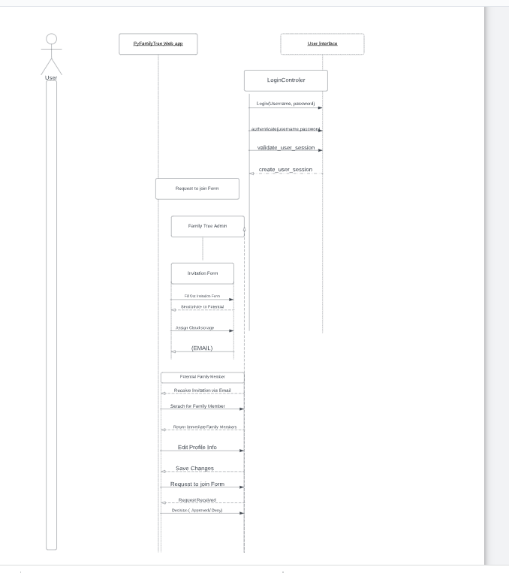

Fig 9.1

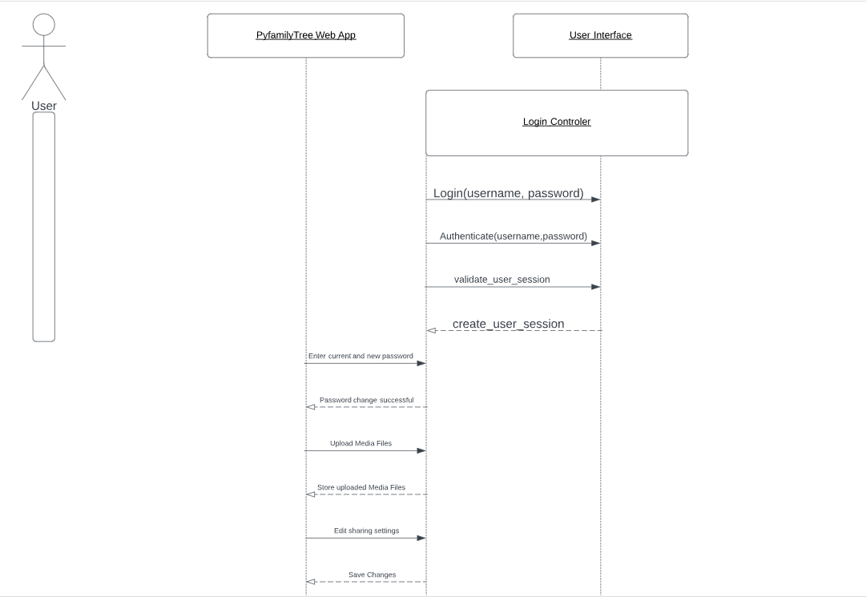

Fig. 9.2

**9.4 Activity Diagrams:**

##### Activity Diagram ID 1: Administer Family Tree

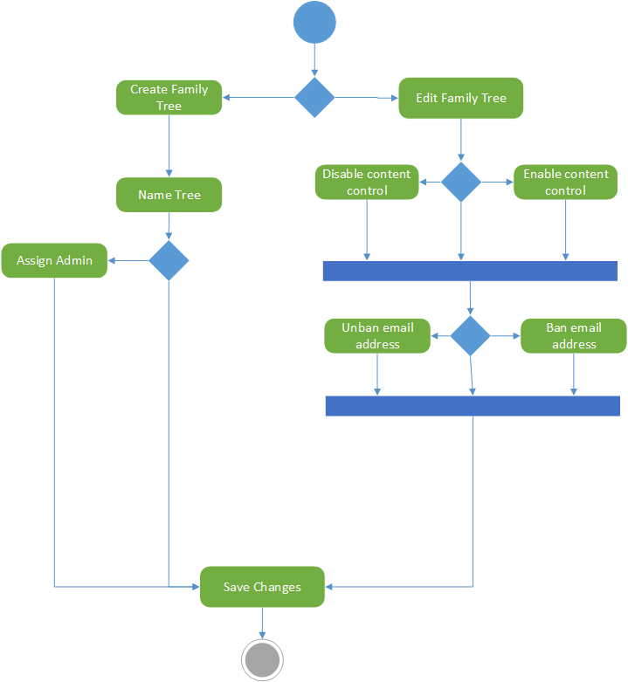

##### Activity Diagram ID 2: Edit Profile

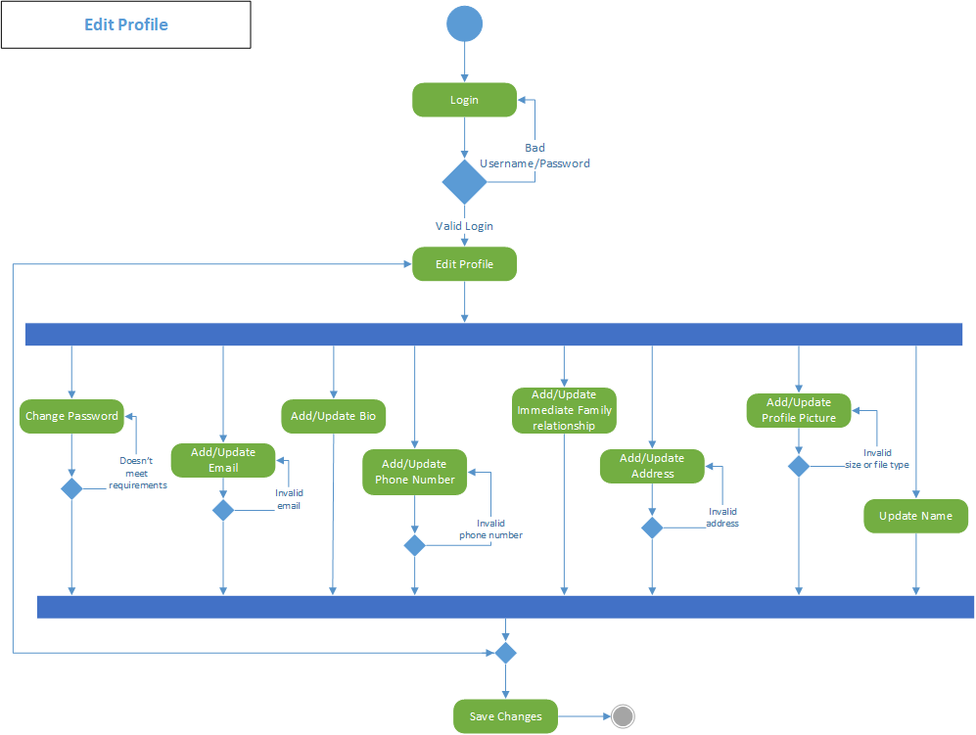

##### 

##### Activity Diagram ID 3: Manage Cloud Storage

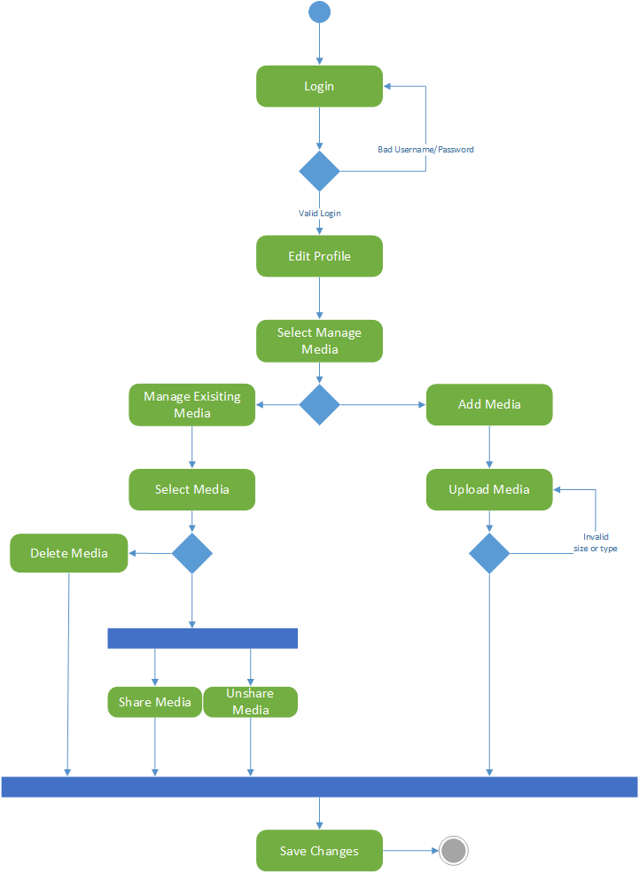

##### Activity Diagram ID 4: New User Activation

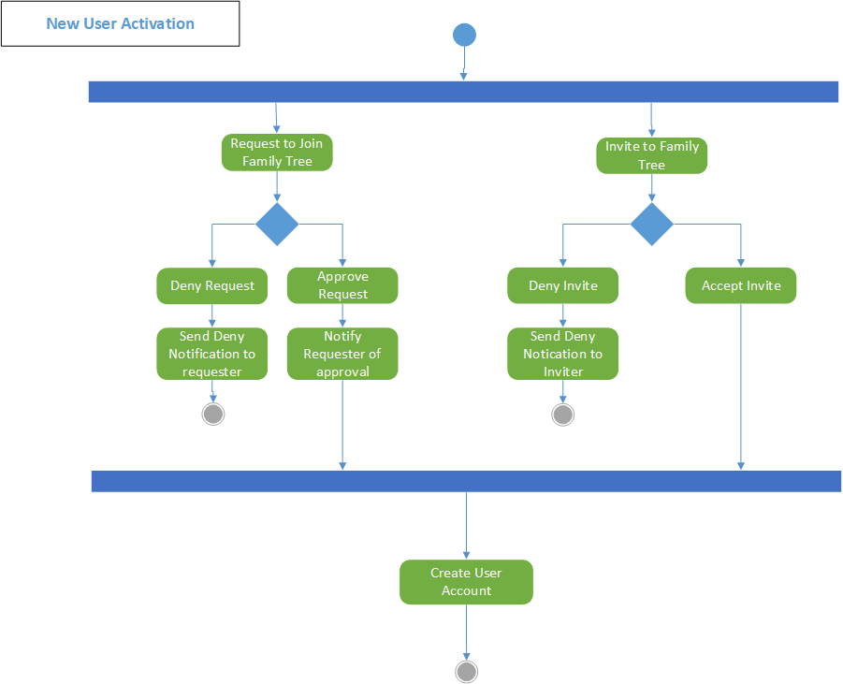

##### 

##### 

##### 

##### 

##### 

##### 

##### Activity Diagram ID 5: Search Family Tree

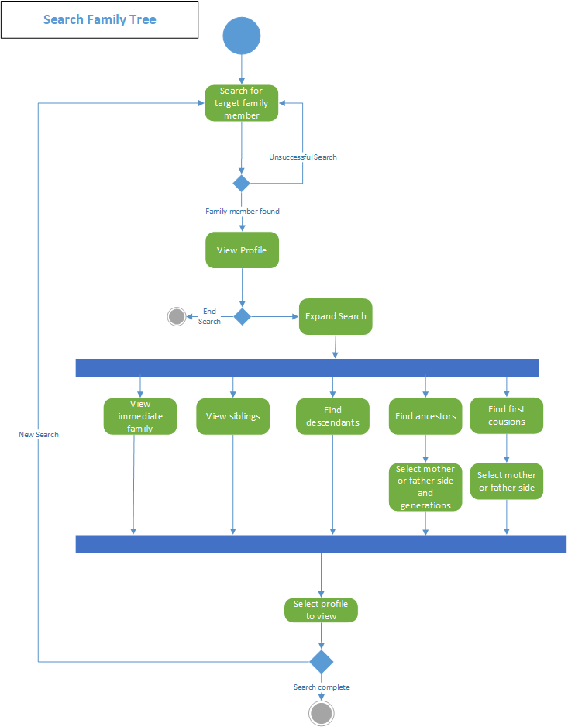

##### Activity Diagram ID 6: Update and Share Media

